A PBL-I Synopsis on
THERAPY CONNECT
Submitted to Manipal University Jaipur
Towards the partial fulfillment for the Award of the Degree of
BACHELORS OF TECHNOLOGY
In Computers Science and Engineering
2025-2026
By
SHRUTI KUMARI
2427010237


Under the guidance of
Dr. Onkar Singh

______________________________
Signature of Supervisor

Department of Computer Science and Engineering
School of Computer Science and Engineering
Manipal University Jaipur
Jaipur, Rajasthan
INTRODUCTION TO PROBLEM
Mental health among students has become one of the most important concerns in today’s world. With increasing academic demands, social pressure, expectations from family, competition, financial stress, and lifestyle changes, students often experience emotional challenges that directly affect their well-being. Many students struggle with problems like stress, anxiety, overthinking, loneliness, low confidence, mood swings, depression, and burnout. These issues, if not identified early, can affect their academic performance, relationships, productivity, self-esteem, and overall quality of life. Although awareness about mental health is increasing, students still hesitate to talk about their emotional problems because of fear, embarrassment, stigma, or lack of proper support systems. This creates an urgent need for accessible, confidential, and student-friendly mental-health support.
Traditional counseling services are helpful, but they come with certain limitations. Many schools and colleges have only a few trained counselors for thousands of students, causing long waiting times. Counseling is available only during working hours, so students in distress at night or during holidays often remain unsupported. Some students live away from home and do not have a strong emotional support system, while others avoid face-to-face therapy because they feel judged or uncomfortable sharing their personal issues. Additionally, the cost of therapy outside campus can be high, making it inaccessible for many students. These gaps show that conventional mental-health systems alone are not sufficient to meet the growing emotional needs of students.

With the rise of technology, online therapy platforms, mobile mental-health apps, and AI-based chatbots have become popular alternatives. They allow students to access support anytime, anywhere, and in complete privacy. These digital tools can provide relaxation techniques, emotional check-ins, guided exercises like cognitive behavioral therapy (CBT), mindfulness practices, and motivational support. However, many existing platforms are not specifically designed for students, and most of them offer generic content that may not suit individual needs. Students often use these apps for a few days and then stop due to lack of personalization, repetitive suggestions, or lack of engagement. This shows that while technology has potential, the current solutions still do not fully address the unique emotional and motivational needs of students.

Therefore, there is a growing need for an Application Based project like “Therapy Connect,” which aims to create a more personalized, interactive, and engaging mental-health platform for students. Instead of offering one-size-fits-all solutions, Therapy Connect focuses on understanding each student’s emotions, behavior patterns, and stress levels. By using AI-driven chatbots, mood tracking, daily check-ins, and interactive wellness activities, the platform can provide timely emotional guidance and coping strategies. It also reduces barriers like stigma, limited counselor availability, and high therapy costs. The platform makes mental-health support more accessible by giving students 24/7 assistance and a safe space to express their feelings without fear of judgment.

Therapy Connect also uses gamified wellness modules to increase student participation and motivation. Small tasks, rewards, progress tracking, and positive reinforcement help students stay consistent in taking care of their mental health. The platform can further integrate teletherapy sessions for students who need deeper emotional support from professional counselors. This creates a blended model where both technology and human guidance work together to improve student emotional well-being.

In summary, the problem lies in the increasing emotional stress among students and the lack of accessible, personalized, and engaging support systems. Therapy Connect aims to solve this problem by offering a digital platform that combines AI-based support, personalization, gamification, and professional therapy options. This makes the project highly relevant, student-centered, and impactful. As an Application Based solution, Therapy Connect uses technology to address a real-world problem and helps create a healthier and more supportive environment for students.

LITERATURE SURVEY

1.Portillo (2025) — Online therapy reduces stress & depression
Summary: Portillo (2025) evaluates online therapy programs aimed at college students and reports measurable reductions in symptoms of stress and depression. The study emphasizes that structured digital interventions (guided CBT modules, psychoeducation, and brief therapist support) can be effective when users complete the recommended activities.
Pros: Scalable delivery to many students; low marginal cost per user; reduces stigma by offering private access.
Cons: Limited ability to manage severe or complex clinical cases; outcomes depend heavily on user engagement and completion rates; risk of dropout if the program is not blended with human support.

2.Cheng (2023) — AI chatbots provide 24/7 support
Summary: Cheng (2023) reviews AI-driven chatbot systems for mental health and highlights their strength as always-available companions that can deliver CBT-style exercises and check-ins. The paper shows that chatbots increase accessibility and can provide timely coping strategies.
Pros: Always-on availability (24/7), immediate responses, low-cost scalability, good for early or mild distress.
Cons: Chatbots often lack deep empathy and clinical judgement; they can provide incorrect or unhelpful advice in complex situations; ethical concerns include user over-reliance, transparency about limits, and data privacy.

3.Lattie (2022) — Gamification increases engagement
Summary: Lattie (2022) studies the use of gamified elements (points, streaks, badges, challenges) in mental-health apps for students. The work shows that gamification raises initial uptake and short-term engagement and can motivate repeated use of therapeutic exercises.
Pros: Increases motivation and daily use; helps build habit formation; can make therapeutic tasks feel less clinical and more approachable for students.
Cons: Engagement gains may be short-lived if mechanics are superficial; some users may focus on rewards rather than learning skills; ethical concern about encouraging dependency on game mechanics rather than intrinsic recovery.

4.Ollio (2022) — Telehealth broadens behavioral care
Summary: Ollio (2022) examines telehealth delivery of behavioral services and finds that remote therapy increases reach (especially for remote or under-served students) and makes specialist care more accessible. The study documents good clinical outcomes when teletherapy is delivered by trained professionals.
Pros: Expands access beyond geographic limits; maintains therapist-led care (better for complex cases); convenient scheduling.
Cons: Less personalized in some contexts (loss of in-person cues), reliance on stable internet and private space, potential digital-literacy barriers and technological failures.

5.CBSE Report (2023) — Tele-MANAS improves student access
Summary: The CBSE Tele-MANAS initiative (2023) is a policy/programmatic effort to provide tele-counseling and mental-health resources to students at scale. Evaluations indicate improved reach and awareness of mental-health services among school communities.
Pros: National coverage and integration with schools; raises awareness and reduces stigma; creates standardized pathways for escalation.
Cons: Programs may be generic and not tailored to individual student needs; resource constraints can limit follow-up and personalization; variable implementation quality across regions.

6.Andersson (2018) — Online CBT improves mental health
Summary: Andersson (2018) synthesizes evidence for internet-based CBT and finds consistent improvements in anxiety and depression scores for many users, especially when some therapist guidance is included. The review shows effectiveness across age groups but highlights adherence as a challenge.
Pros: Evidence-based approach with strong theoretical grounding; effective for mild-to-moderate conditions; structured modules are easy to scale.
Cons: Requires user discipline and consistency to gain benefit; pure self-guided versions show higher dropout; may be less effective for complex comorbidities.

7.Peer Support Models — Encourage emotional sharing
Summary: Studies of peer support platforms and moderated groups show that peer models encourage emotional disclosure, normalize experiences, and create a supportive community that can reduce isolation among students. These are often implemented as forums, peer-led groups, or moderated chat networks.
Pros: Builds social connection and belonging; low cost; can be culturally resonant and reduce stigma.
Cons: Lack of professional oversight raises safety concerns (misadvice, triggering content); peer helpers need training and supervision; not suitable as sole intervention for severe disorders.

8.AI Prediction Models — Detect early emotional distress
Summary: AI prediction systems analyze behavioral signals (app usage, text, sleep/phone sensors) to identify early signs of stress, anxiety, or depression. Research shows promising predictive accuracy in controlled samples and potential for early intervention.
Pros: Preventive potential—can flag at-risk students early; enables targeted outreach and resource allocation; supports data-driven monitoring.
Cons: Requires large, representative datasets for reliable models; privacy and consent are major ethical issues; risk of false positives/negatives and potential stigmatization.

9.Hybrid Therapy Models — AI + therapist supervision works best
Summary: Hybrid models combine automated AI tools (chatbots, screening, self-help modules) with human therapist oversight or stepped-care escalation. Evidence indicates hybrid approaches optimize scalability while maintaining clinical safety and better outcomes than pure self-help or purely automated systems.
Pros: Balances efficiency and clinical safety; improves retention and outcomes through human touchpoints; provides clear escalation for severe cases.
Cons: Resource-intensive compared to fully automated systems; requires coordination between tech and clinical teams; higher operational complexity.

COMPARATIVE STUDY

Method / Technology | Advantages | Disadvantages
AI Chatbots | 24/7 support, scalable | Lacks empathy, possible inaccuracies
Teletherapy | Human connection, reliable | Costly, limited availability
CBT Apps | Structured, proven | High dropout rates
Gamified Apps | High engagement, interactive | Ethical risks, dependency
Hybrid AI + Human Model | Balanced, effective | Resource intensive

PROBLEM STATEMENT

Student mental health has become a critical concern worldwide as increasing academic pressure, competitive environments, social expectations, financial stress, and personal challenges negatively impact emotional and psychological well-being. Many students experience symptoms such as anxiety, stress, depression, loneliness, burnout, and low self-esteem, yet hesitate to seek help due to stigma, fear of judgment, limited awareness, or lack of access to affordable and timely mental-health services. Traditional counseling systems, although effective, often face major limitations including long waiting periods, shortage of trained professionals, high costs, rigid scheduling, and limited availability, especially in college and university settings where student populations are large and diverse. At the same time, although digital mental-health tools such as online therapy platforms, mobile self-help apps, and AI-based chatbots have emerged as promising solutions, they frequently suffer from low engagement, poor personalization, generic content, insufficient emotional sensitivity, and limited support for severe or complex psychological needs. Many existing platforms fail to adapt to students’ unique emotional states, learning patterns, and motivational levels, resulting in users abandoning the tools after initial use. The lack of an integrated, student-centered mental-health platform that combines accessibility, personalization, continuous emotional support, engaging therapeutic activities, and reliable escalation pathways leads to unmet mental-health needs and widening emotional gaps among students. Therefore, there is a strong necessity for a comprehensive solution like “Therapy Connect,” which aims to bridge these limitations by offering a blended approach that integrates AI-driven emotional support, real-time mood tracking, personalized coping strategies, online counseling options, and gamified therapeutic modules to ensure that students receive consistent, confidential, affordable, and effective mental-health support that fits their daily routines and individual needs.

OBJECTIVES

- To provide an accessible and student-friendly digital platform that offers emotional support, mental-wellness guidance, and therapeutic tools anytime and anywhere.
- To reduce stress, anxiety, and emotional burden among students by offering AI-driven interventions such as mood tracking, guided relaxation, CBT-based advice, and emotional check-ins.
- To personalize mental-health assistance using AI-based mood detection, user history, and behavioral patterns so that students receive support tailored to their individual needs.
- To increase student engagement in mental-wellness activities by incorporating gamification features such as rewards, progress tracking, daily tasks, and motivational prompts.
- To bridge the gap between students and professional counseling by integrating teletherapy features that allow escalation to trained mental-health experts when needed.
- To create a safe, confidential, and stigma-free environment where students can express their thoughts and emotions without fear of judgment.
- To evaluate the effectiveness of digital therapeutic tools in improving students’ emotional well-being and helping them build healthy coping skills.

PLANNING OF WORK/PROPOSED SOLUTION

The development of Therapy Connect follows a systematic and structured methodology to ensure that the final application is user-friendly, reliable, and effective in supporting student mental health. The methodology includes multiple planned stages, starting from problem identification to prototype development, testing, refinement, and deployment. Each phase plays a crucial role in meeting the objectives of accessibility, personalization, emotional support, and continuous student engagement.

1. Problem Identification and Requirement Analysis
The first stage involves understanding the exact challenges students face in managing stress, anxiety, and emotional difficulties. Surveys, interviews, and existing research are reviewed to identify key issues such as lack of accessibility, hesitation in seeking help, unavailability of counselors, and low engagement in existing digital mental-health tools. Based on this, the core requirements of Therapy Connect are defined, such as 24/7 availability, privacy, personalization, simple language, and a user-friendly interface suitable for students of all backgrounds.

2. Research on Existing Solutions
This step focuses on analyzing current mental-health tools, AI chatbots, counseling platforms, wellness apps, and gamified therapeutic modules. Their strengths and weaknesses are studied to identify gaps such as low personalization, lack of student-specific content, limited emotional sensitivity, and insufficient features for motivation or habit-building. Insights from literature review guide the design choices for developing a more effective student-centered platform.

3. System Design and Architecture Planning
In this stage, the overall structure of Therapy Connect is planned. This includes dividing the system into different modules and defining how each module will interact.
3.1 Major System Components
- AI-Based Chatbot Module: For emotional conversations, mood tracking, and instant guidance
- User Interface (UI/UX): A clean, simple, interactive interface designed for student comfort
- Gamified Mental-Wellness Module: Includes tasks, rewards, progress trackers, streaks
- Teletherapy/Professional Support Module: Option to connect with trained counselors
- Database Module: Secure storage of user profiles, mood logs, and activity history
- Analytics Module: Tracks behavioral trends and provides personalized insights
3.2 Flow of System
- Student logs into Therapy Connect
- AI chatbot conducts a mood check-in
- System recommends personalized activities
- Gamified tasks improve engagement
- If distress persists, system suggests professional counseling
- Progress dashboard displays improvements over time
System design ensures that the platform follows a smooth, logical flow and remains easy to navigate.

4. UI/UX Design and Wireframing
Before developing the actual application, screens and layouts are sketched and designed:
- Login/Signup page
- Home dashboard
- Chatbot screen
- Mood check-in screen
- Activity & task section
- Counseling booking page
- Analytics and progress tracker
The goal is to make the platform intuitive, attractive, and student-friendly. Visual mockups help finalize color themes, icons, fonts, and navigation structure.

5. Development Phase
This phase involves the actual creation of the Therapy Connect application.
5.1 Frontend Development
- Building the user interface
- Designing buttons, chat windows, forms, and navigation bars
- Ensuring responsiveness across devices
5.2 Backend Development
- Creating server-side logic for chatbot responses
- Handling user authentication and database connectivity
- Storing emotional logs, chat history, activity progress
5.3 AI Chatbot Integration
- Implementing NLP-based conversational flow
- Training the chatbot to detect emotions from text
- Adding CBT-based guidance, breathing exercises, journaling prompts
- Ensuring safe and sensitive responses
5.4 Gamification Development
- Designing reward systems, badges, and streak counters
- Creating daily tasks and wellness challenges
- Ensuring that gamification supports therapeutic goals

6. Testing and Feedback Collection
Testing ensures that the platform is stable, accurate, and user-friendly.
6.1 Types of Testing
- Functional Testing: To check whether all features work as expected
- Usability Testing: Conducted with students to see how easy the platform is to use
- Performance Testing: Ensures the app works smoothly during high usage
- Chatbot Testing: To check emotional sensitivity, accuracy of responses, and safety
- Security Testing: Ensures that user data is fully protected
6.2 Feedback Gathering
Students and mental-health professionals are asked to use the prototype and provide feedback. Suggestions are recorded and used to improve both UI and features.

SCREENSHOTS

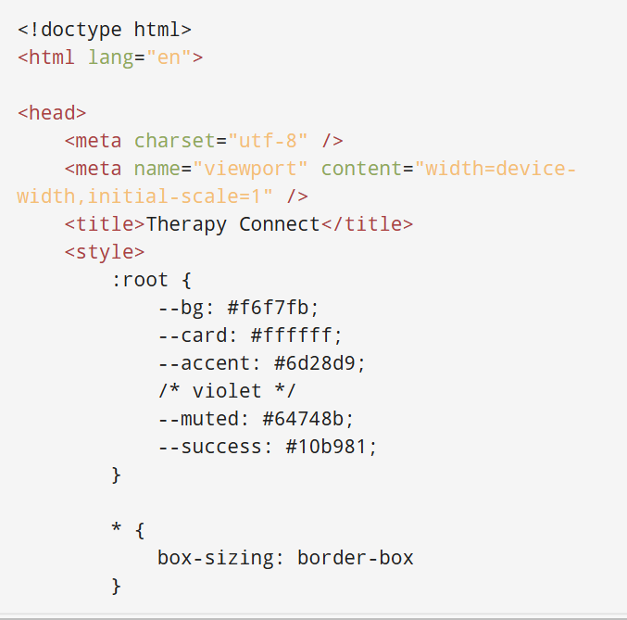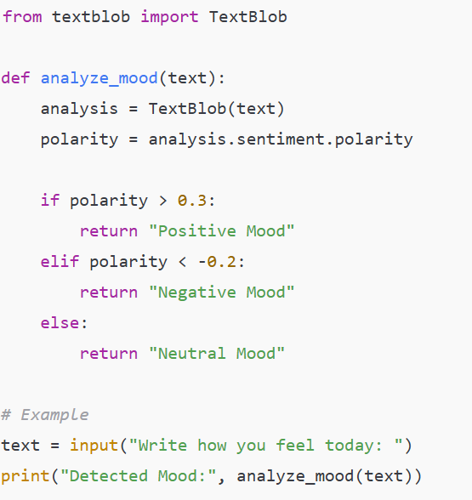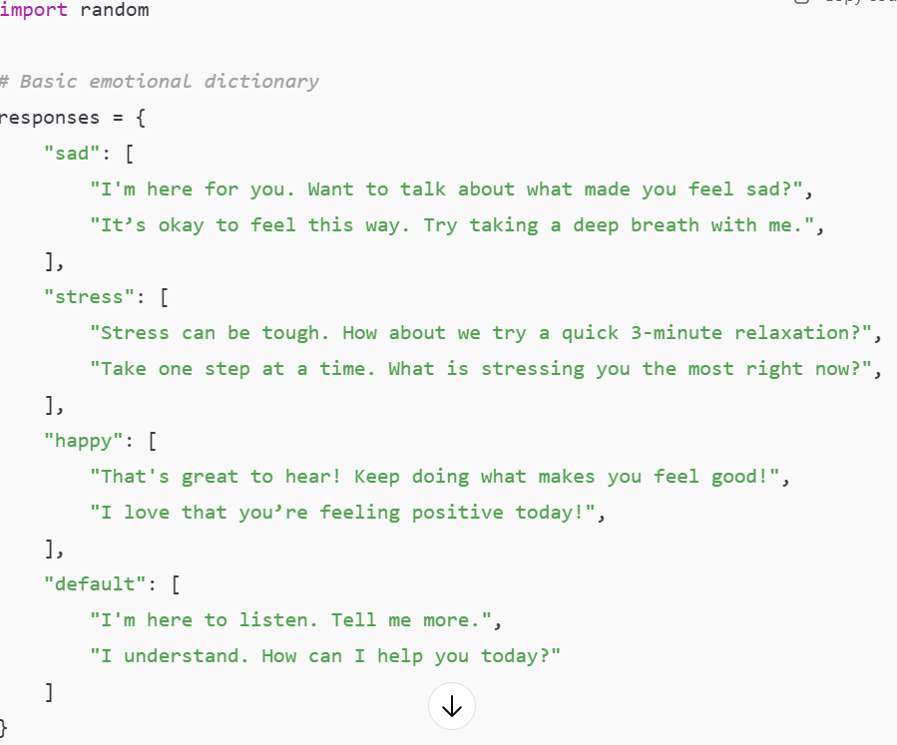

1. Frontend Development:
• Focuses on designing and building the user interface of Therapy Connect.
• Includes landing page, chatbot interface, mood check panel.
• Developed using HTML, CSS, JavaScript.
• Ensures the platform is responsive, user-friendly, and visually appealing.
• Handles all user interactions such as sending messages, clicking mood
buttons, and navigating pages.
⸻2. Backend Development:
• Manages all the logic, data processing, and system operations behind the
Platform.
• Handles chatbot response generation, user data storage, and session
Management.
• Integrates AI/ML APIs to produce automated emotional-support messages.
• Ensures security, data flow, and communication between frontend and
Backend.

BIBLIOGRAPHY / REFERENCES

1. Fischer-Grote, L., Fössing, A., Tegethoff, M., & Meinlschmidt, G. (2024). Effectiveness of Online and Remote Interventions for Mental Health in Children, Adolescents, and Young Adults: A Systematic Review and Meta-Analysis. BMC Psychiatry. https://doi.org/10.1186/s12888-024-06046-x
2. Reyes-Portillo, J. A., et al. (2025). Generative AI–Powered Mental Wellness Chatbot for College Student Mental Health: Open Trial Results. JMIR Formative Research. https://doi.org/10.2196/71923
3. Cheng, C. (2023). Gamification: A Novel Approach to Mental Health Promotion. Current Psychiatry Reports, Springer. https://doi.org/10.1007/s11920-023-01318-0
4. Lattie, E. G., Cohen, K. A., & Hersch, E. (2022). Uptake and Effectiveness of a Self-Guided Mobile App for College Student Mental Health. Internet Interventions, Elsevier. https://doi.org/10.1016/j.invent.2021.100433
5. Ollio, J., et al. (2022). Using Telehealth to Provide Behavioral Healthcare: Review and Recommendations. Journal of Clinical Medicine. https://doi.org/10.3390/jcm11061518
6. Central Board of Secondary Education (CBSE). (2023). Tele-MANAS Mental-Health Support Initiative for Students. Times of India Report.
7. Andersson, G. (2018). Internet-Based Cognitive Behavioral Therapy for Students: A Review of Evidence. Journal of Medical Internet Research. https://doi.org/10.2196/jmir.9871
8. D’Adamo, L., Glicken, S., & Horvath, M. (2024). Reach and Uptake of Digital Mental-Health Interventions in University Populations. European Child & Adolescent Psychiatry. https://doi.org/10.1007/s00787-024-02404-y
9. Aschentrup, L., et al. (2024). Effectiveness of Gamified Digital Interventions for Mental Health: A Systematic Review. Frontiers in Psychology.
10. Xu, M., Zhang, Y., & Li, C. (2025). AI-Based Chatbots for Student Well-Being: Challenges and Opportunities. Frontiers in Psychiatry.

